ORDER FORM
Order No.: Date: Quantity:
Name of Client: Tel:____________________________
Regular Order(22-25 days):_________ Rush Order(15 days):_________ Super Rush Order(10-12 days):________
Type of Hair: Indian Remy Human Hair 100% Chinese virgin Hair 100% Indian virgin Hair 100% _______ Brazilian Hair 100% Malaysian Hair 100% European Hair 100%
Hair Texture & Curl: ( ) As picture
Hair Length:
Hair Color: ( ) As picture
Hair Density: ( ) 80% ( ) 100% ( ) 130% ( )140% ( )150% customized
Baby Hair: ( ) None ( ) Front Only ( ) Around Entire Perimeter
Baby Hair Type: ( ) None ( ) Straight ( ) Curly ( ) Wavy
Type of Knots: ( ) General Knots ( ) Bleached Knots ( ) Others____________
Hair Parting: ( ) Free Style (flat back) ( ) Right Part ( ) Left Part ( )Center Part

Cap Construction
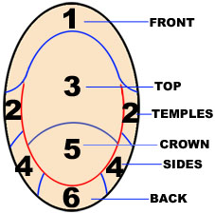  If you are getting high-lights please let me know the area that you want each color | Cap Design:  1.[ ] Lace Front Wigs(1-2-3 is lace, other area is stretch lace)  2.[ ] Full lace wigs  2-1( ) With a little Stretch Lace From ear to ear no pu  2-2( ) With a little Stretch Lace From ear to ear with pu  2-3( ) Without Stretch Lace.  3. [ ] Full thin Skin, all head is thin skin.  4. [ ] thin skin around perimeter，lace around the head, with a little stretch lace from ear to ear  5. [ ]Silky top/Hidden knots  6. [ ] customized_________________  Lace Color: [ ] dark brown [ ] brown [ ] light Brown [ ] light(transparent)  Lace Type: [ ] Swiss [ ] French
Cap Size
[ ] Large [ ] Medium [ ] Small [ ] Customized
Head Measurement Template
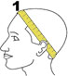 Circumference 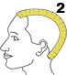 Forehead to Nape
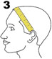 Ear to ear across front hairline 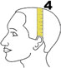 Ear to ear over top
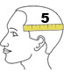 Temple to temple round back 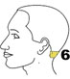 Nape of Neck

Size(inches): 1 _ 2 _ 3 _ 4 _ 5 _ 6 __ __ __
Note: you can logon my website: http://www.cooperwigs.com/Cap_construction.htm to find < cap construction> to find detailed information.
Friendship Reminding:
Please make sure that you make your head measurement in this way shown in the above pictures. Right measurement is very important for us to make right wig for you. If the measurement is not right, the lace wig will not work because we will exactly make the wig according to your measurement size. We are not responsible for the wrong measurement.
Shipping Address:
Special Instruction

